**Network Simulator – 2 Report**

Fabiha Tasneem – 1805072

**Wireless MAC Type: 802.11**

The IEEE 802.11 MAC protocol is a set of rules that define how devices in a wireless local area network (WLAN) should communicate with each other. It operates at the data link layer (layer 2) of the OSI reference model and specifies how data is transmitted over the air between devices.

The basic service set (BSS) is a group of stations that are connected to the same access point and operate within the same radio coverage area. An extended service set (ESS) is a group of BSSs that are connected through access points and operate as a single network. A portal is a device that connects a WLAN to other wired networks, such as the internet. The distribution system is a logical interconnection network that is based on multiple BSSs and is used to distribute data throughout the network.

**Routing Protocol: DSDV**

Destination Sequenced Distance Vector (DSDV) is a routing protocol designed for use in ad hoc networks, which are networks that do not have a central infrastructure and rely on devices to communicate with each other directly. DSDV is a widely used routing protocol in ad hoc networks due to its fast convergence and ability to prevent loops and the count-to-infinity problem.

DSDV operates at the network layer (layer 3) of the OSI reference model and is a proactive, table-driven protocol that uses a routing information update mechanism to maintain and disseminate routing information throughout the network.

DSDV is based on the Bellman-Ford single source shortest path (SSSP) algorithm and includes several features to improve its performance.

**Agent: UDP**

User Datagram Protocol (UDP) is a connectionless and unreliable protocol that operates at the transport layer (layer 4) of the OSI reference model. It is a simple protocol that is used to transmit small messages without the need for reliability or error checking.

UDP is a good choice for applications that need to send data in one direction and do not require the overhead of a reliable connection. It is often used in query-based communication, where a process sends a small message to request information and the response is returned using a separate message.

UDP is a very fast protocol compared to other transport layer protocols such as Transmission Control Protocol (TCP) and Stream Control Transmission Protocol (SCTP), as it does not have the overhead of establishing and maintaining a connection or providing error checking. However, this also means that it does not provide the same level of reliability as TCP or SCTP.

**Application: Exponential Traffic**

Exponential bit rate traffic refers to a type of traffic that has an exponentially increasing bit rate over time. This type of traffic is often used to simulate the behavior of real-world traffic in networking and communication systems, as it can better represent the complexity and variability of real-world traffic patterns. In this case, the exponential bit rate traffic would represent the amount of data being transmitted over the network using UDP.

**Graphs**

**Parameter: Area Size**

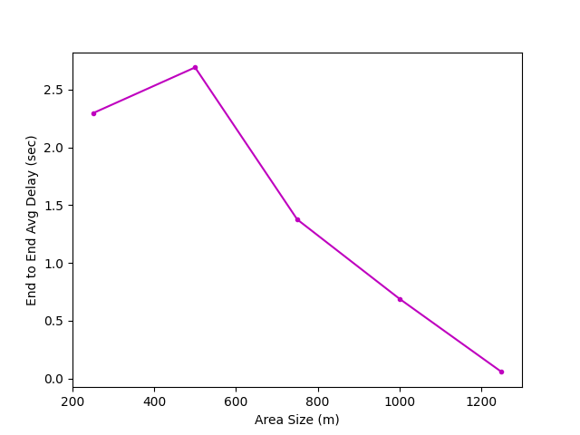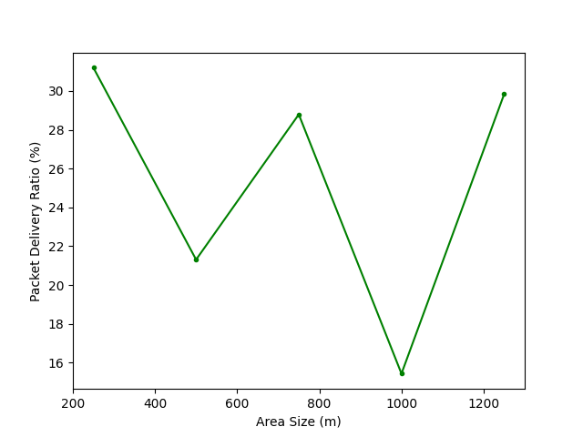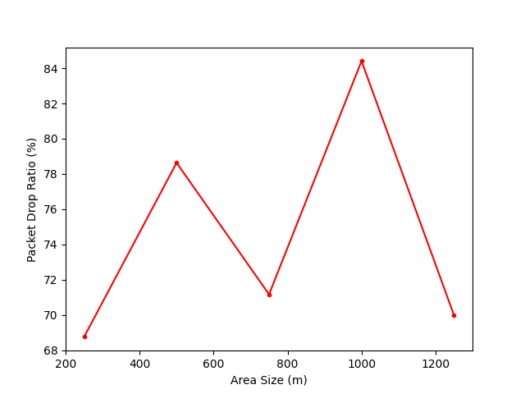

**Parameter: Number of Nodes**

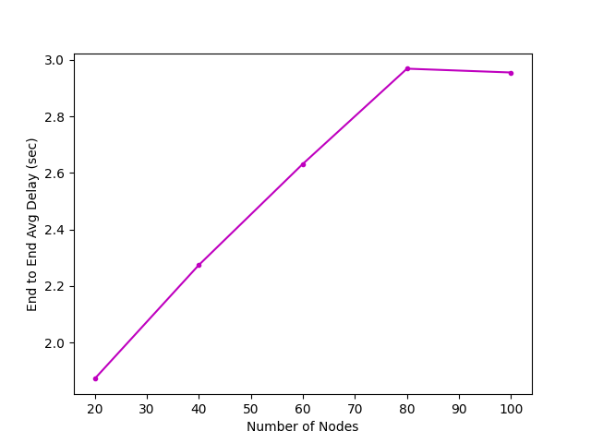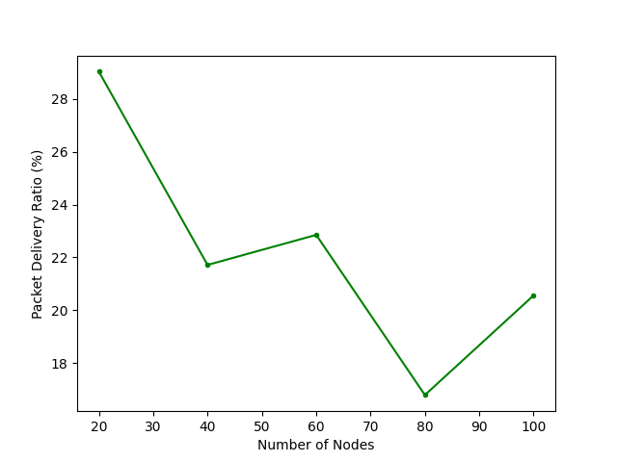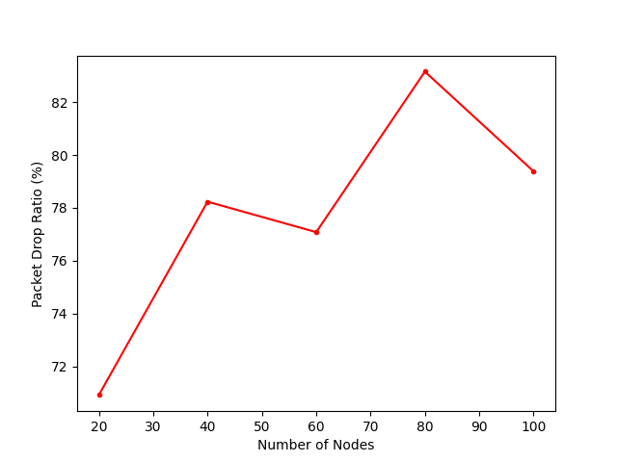

**Parameter: Number of Flows**

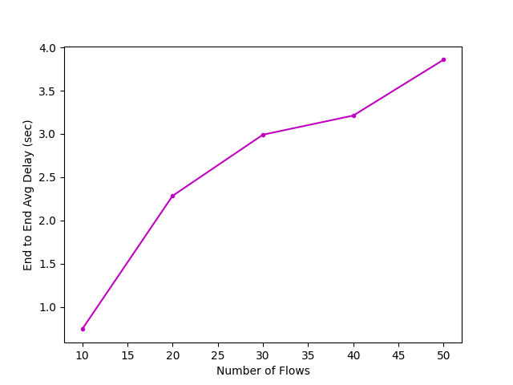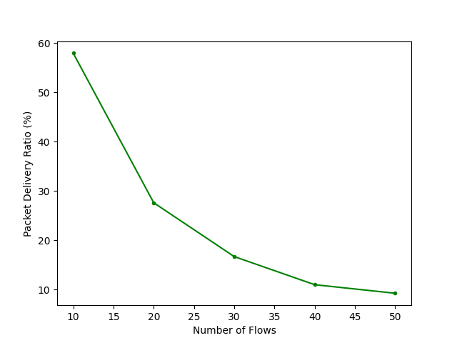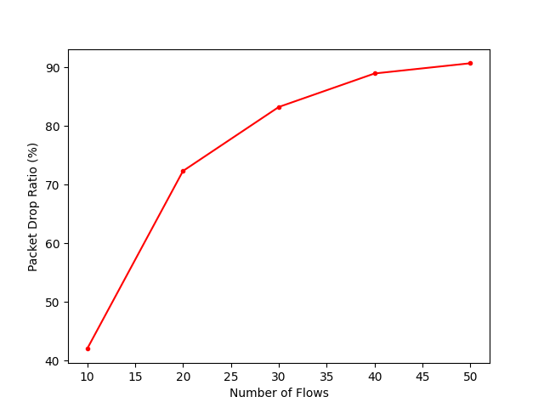

**Observations**

These observations highlight some of the key characteristics and challenges of communication in ad hoc networks:

1. In ad hoc networks, the throughput and end-to-end delay of packet transmission can be affected by a variety of factors, such as the distance between nodes, and the number of competing flows in the network. In general, networks with lower throughput tend to have higher end-to-end average delays for packet transmission.
2. UDP is an unreliable protocol because it does not provide error checking or acknowledgement of received packets. This means that some packets may be lost in the network, and there is no mechanism to retransmit lost packets. This can result in a higher packet drop rate and lower packet delivery ratio.
3. The irregularity in packet transmission in ad hoc networks can be caused by the random placement and movement of nodes, which can lead to changes in the network topology and affect the path that packets take to reach their destination.